1. **Beet Seed**

**Завдання:** Протестуй роботу сайту “[канцтовар.укр](https://www.xn--80aaf4aqgqm9a.xn--j1amh/) ” на мобільному пристрої.

Виконання завдання:

1. **Name:** BOTTOM OF EVERY PAGE - Part of the text missed in mobile version.

**Description:** in the mobile version of the site, at the bottom of every page, some part of the text is missing.

**Steps to reproduce:**

1. Open the website on a mobile device.

2. Scroll to the end of the page.

3. Find the text "МИ ПРИЙМАЄМО: готівку, приват24".

**Actual result:**

We see only ": готівку, приват24" text. The part with "МИ ПРИЙМАЄМО" isn’t showing.   
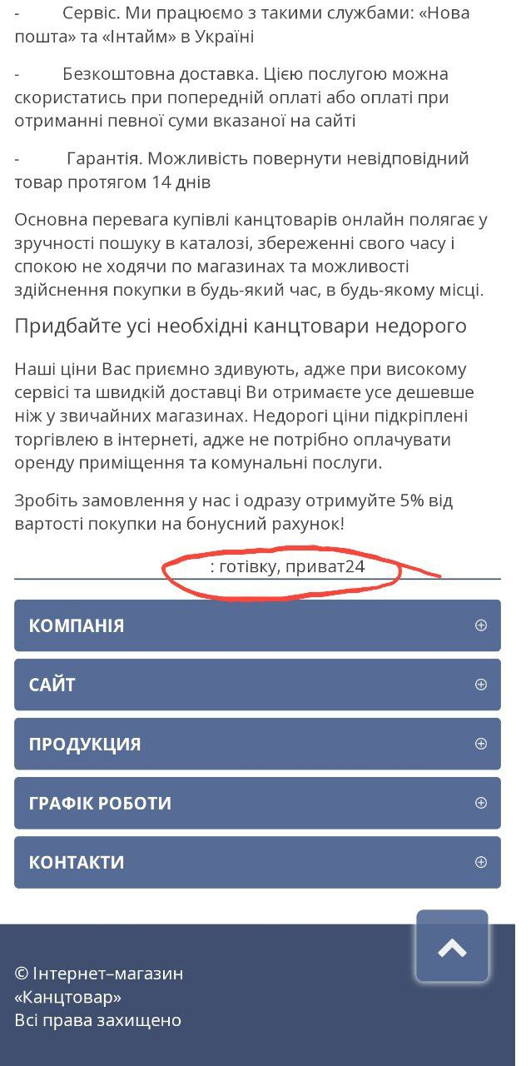  
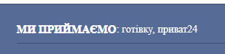

**Expected result:**

All text should be visible.

2. **Name:** THE MOBILE VERSION OF THE SITE - Only empty top of the site visible in landscape mode on the phone.

**Description:** when I turn my phone to landscape mode, a big gray block from the top of the site blocks the view of other parts of the site.

**Steps to reproduce:**1. Open the website on a mobile device.

2. Turn your phone to landscape mode.

**Actual result:**  
The big gray block at the top of the site blocks the view of other parts. We can scroll the page for only a few seconds, but then the gray block gets bigger, making it impossible to see anything else.

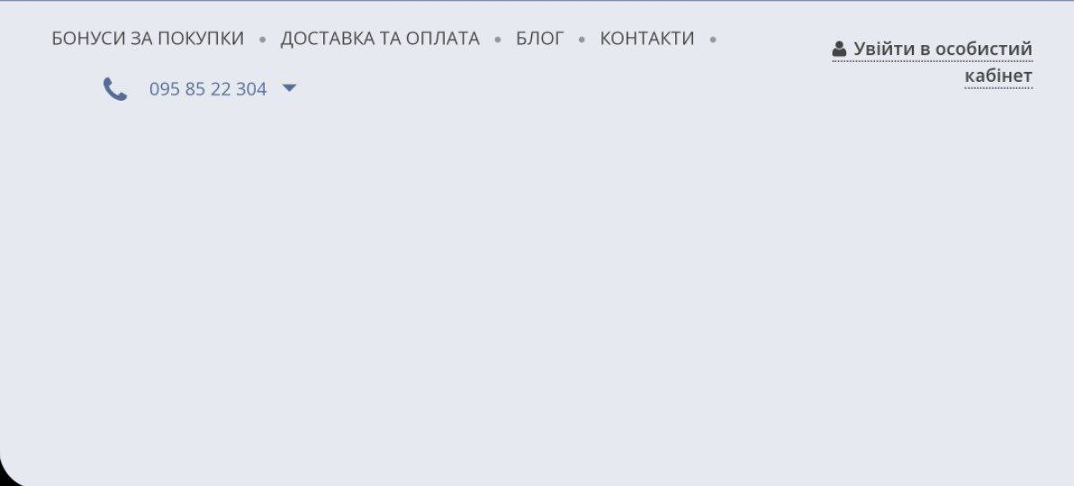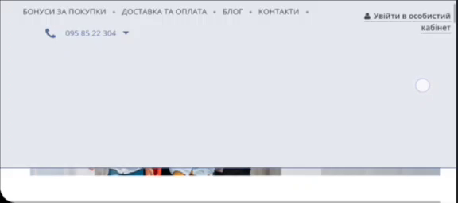

**Expected result:** All parts of the site should be visible, and we should be able to interact with them.

3. **Name:** THE FRONT PAGE - Characters in the navigation bar aren't displayed.

Description: on the front page, there is a navigation bar with three pop-up buttons. They work, but the characters or names of these buttons aren’t displayed.

**Steps to reproduce:**

1. Open the website on a mobile device.  
2. Look at the navigation bar.

**Actual result:**

We see three unknown symbols.

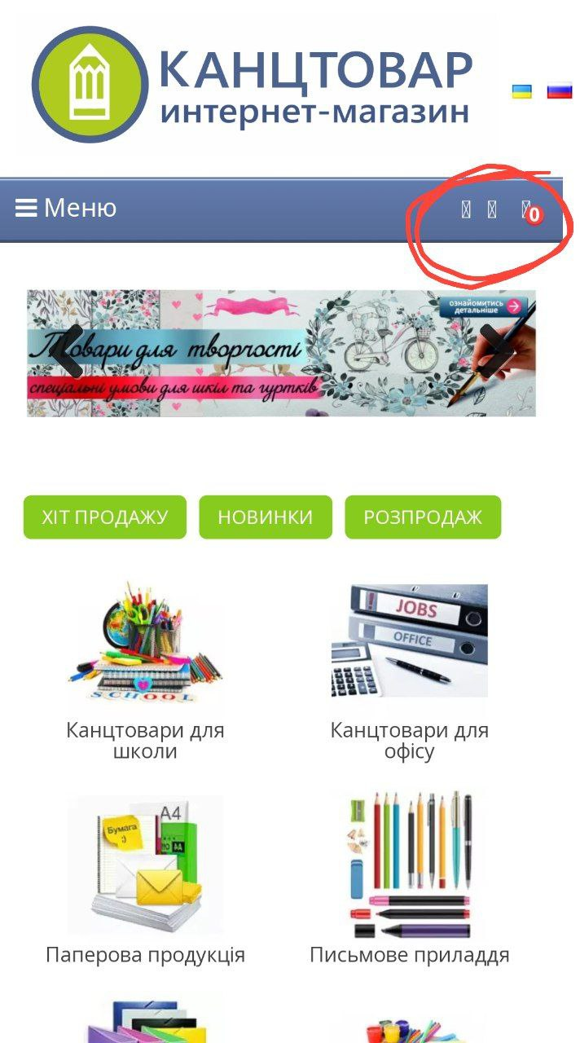

**Expected result:**

There should be three symbols or text for “Бажане”, “Порівняння”, and “Корзина”.

4. **Name:** THE FILTER - The page counter text is incomprehensible.

**Description:** when I use product filters, there is a page counter at the bottom of the page. It counts not only the pages but also the products on the page, without indicating that it is counting products, making it incomprehensible.

**Steps to reproduce:**

1. Open the website on a mobile device.

2. Click the “Меню” on navigation tab.

3. Click any of the categories and pick any of the products.

4. Scroll to the words “Показано … по … із … (всього сторінок: …)”.

**Actual result:**

The counter displays both pages and products without clarifying what is being counted.

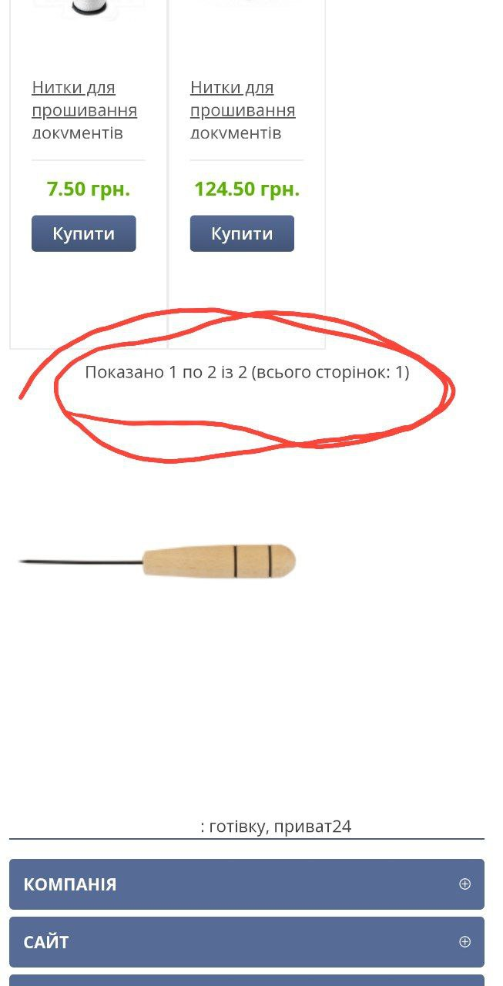

**Expected result:**   
There should be clear indicators of what is being counted. The counter should only display the number of pages.

5. **Name:** THE NAVIGATION TAB - The categories line in the menu can expand, but can’t shrink.

**Description:** when I click on the categories in the menu, it shows product names. However, when I click a second time, the category line doesn’t shrink and still shows the product names.

**Steps to reproduce:**

1. Open the website on a mobile device.

2. Click the “Меню”.

3. Click any of the categories.

4. Click the same category a second time.

**Actual result:**

The categories line shows product names, but when I click the same category a second time, the categories line does not shrink and continues to display the product names.

P.S. I will send you a video in LMS because I can't add it to Google Docs.

**Expected result:**

When I click a category a second time, the category line should shrink.

1. **Beet Sprout**

**Завдання:** Встанови будь-який емулятор.

**Виконання завдання:** встановила BlueStacks.

**Завдання:** Знайди 3 баги на сайті “Звірополіс”. Додай їх в документ з баг репортами з попереднього рівня.

**Виконання завдання:**

1. **Name:** THE PAGE “КОНТАКТИ” - The maps on the page are not visible.

**Description:** when i go to the page “Контакти” i see a place for google maps but it isn’t showing on the screen.

**Steps to reproduce:**

1. Open the website in the mobile version.

2. Go to page “Контакти”.

3. Look for the maps and related information.

**Actual result:**

The maps are not visible, only text is displayed.

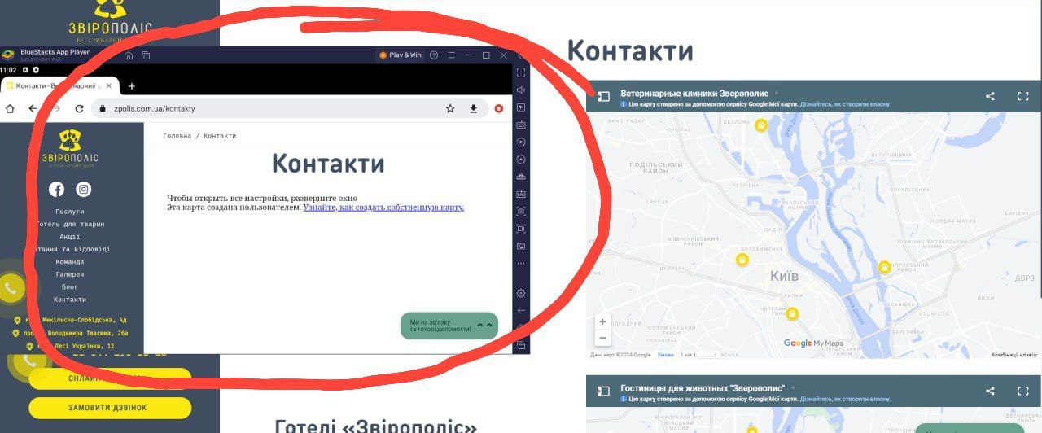

**Expected result:**

The maps should be visible.

2. **Name:** THE “АКЦІЇ” PAGE - Expired promotions are not removed, causing confusion.

**Description:** the website does not remove expired promotions and still allows users to submit requests for these promotions, leading to user confusion.

**Steps to reproduce:**

1. Open the website in the mobile version.

2. Go to page “Акції”.

3. Find and select a promotion that has expired.  
4. Attempt to submit a request for the expired promotion.

**Actual result:**  
Expired promotions are still visible, and users can submit requests for them, which can cause confusion.

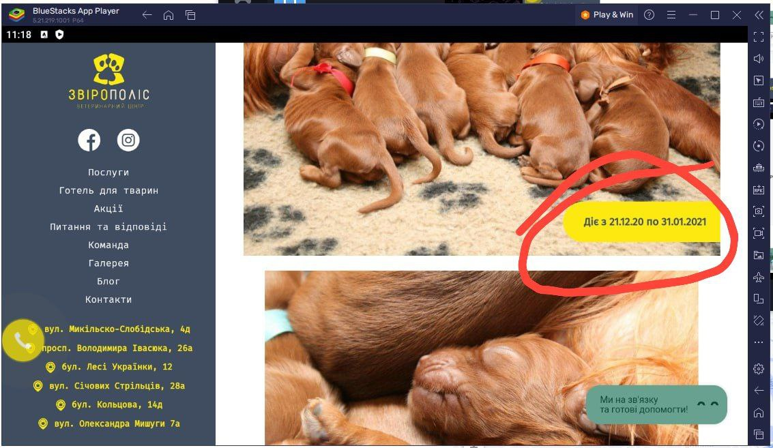

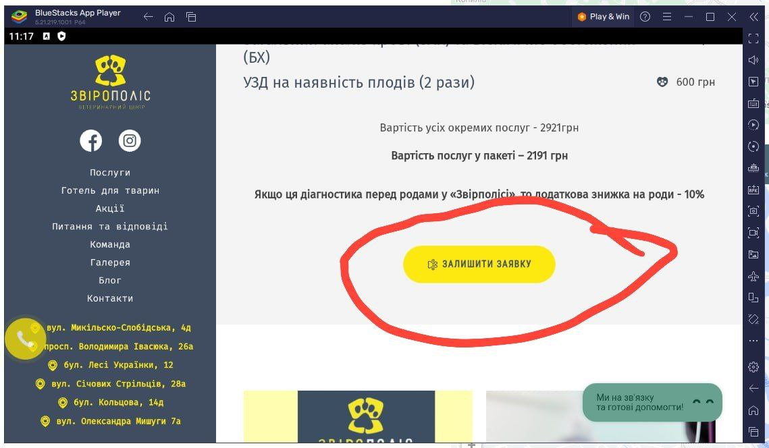

**Expected result:**

Expired promotions should be removed from the website, or it should be clearly indicated that the promotion has expired and requests cannot be submitted.

3. **Name:** THE “ПИТАННЯ ТА ВІДПОВІДІ” PAGE - Unable to scroll to the bottom, but can interact with off-screen elements.

**Description:** the bottom part of the site is beyond the screen's view, and I cannot scroll down to it. However, I can still interact with elements (e.g., buttons) in this area, even though I can only see their edges.

**Steps to reproduce:**

1. Open the website in the mobile version.

2. Go to page “Питання та відповіді”.

3. Scroll to the bottom of the page.  
4. Attempt to interact with the buttons or elements that are partially visible off-screen.

**Actual result:**

The bottom part of the site is not fully visible, and I cannot scroll to see it completely. I can still interact with elements in this area, but I can only see their edges.

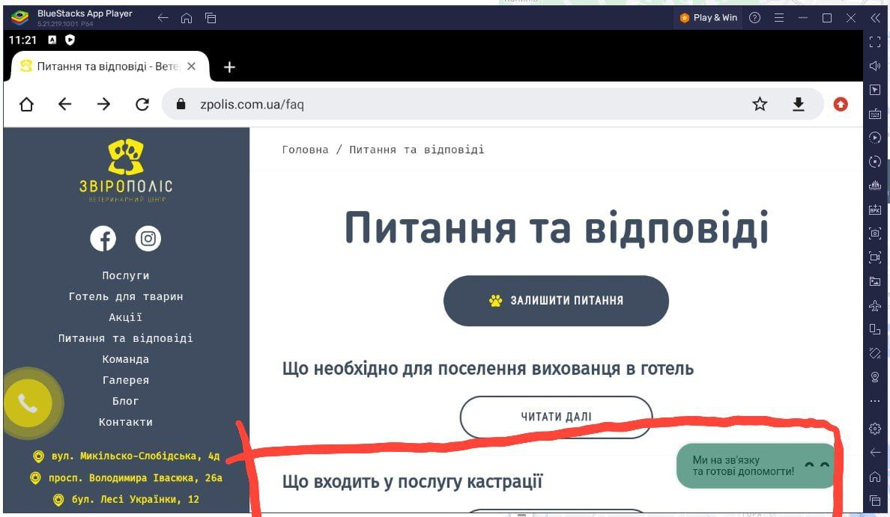

**Expected result:**

The bottom part of the site should be fully visible and accessible by scrolling. All interactive elements should be fully viewable and identifiable.